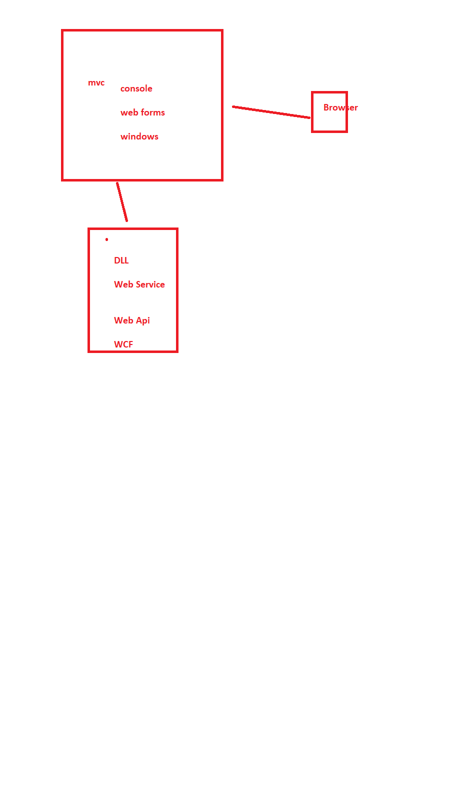

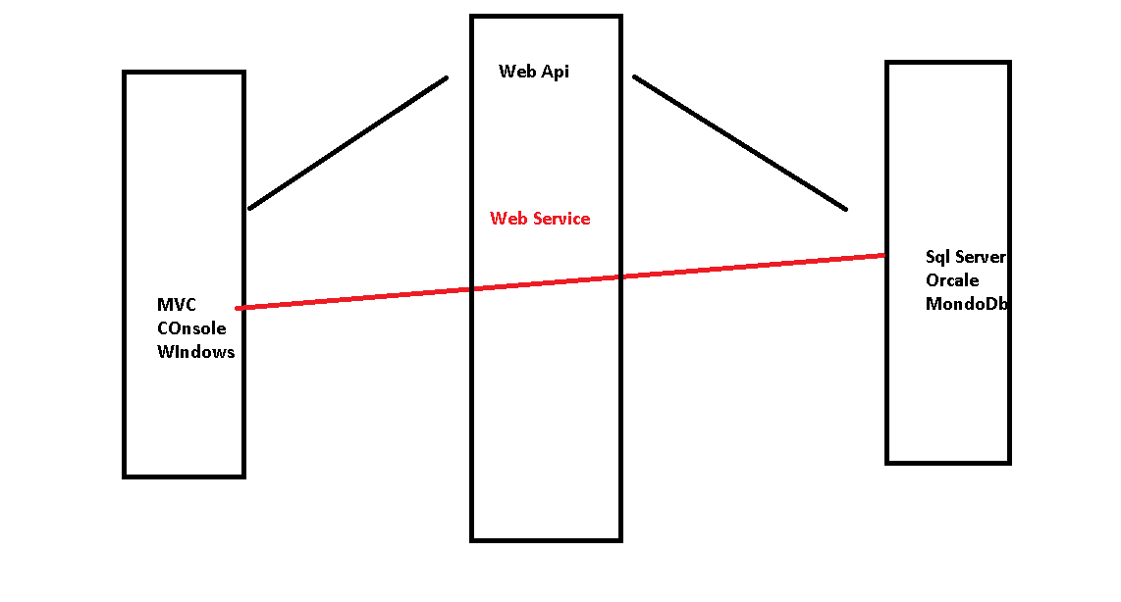

@Html.BeginForm()

{

@html.Lablkefor()

@Html.TetBoxFor()

<button type=submit> Submit </button>

}

-------------------------------------------------------------------------------------------

**Using HttpResponseMessage**

using System;

using System.Collections.Generic;

using System.Linq;

using System.Net;

using System.Net.Http;

using System.Web.Http;

using FirstWebApi.Models;

namespace FirstWebApi.Controllers

{

public class Students1Controller : ApiController

{

static List<Student> students = null;

public Students1Controller()

{

if(students == null)

{

students = new List<Student>()

{

new Student() { StudentId = 1, Name = "Ajay", Batch = "B001", Marks = 90, DateOfBirth = Convert.ToDateTime("12/12/2001") },

new Student() { StudentId = 2, Name = "Deepak", Batch = "B003", Marks = 78, DateOfBirth = Convert.ToDateTime("10/06/2020") },

new Student() { StudentId = 3, Name = "Sagar", Batch = "B002", Marks = 98, DateOfBirth = Convert.ToDateTime("10/06/2020") },

new Student() { StudentId = 4, Name = "Pradeep", Batch = "B002", Marks = 80, DateOfBirth = Convert.ToDateTime("10/06/2020") }

};

}

}

// GET: api/Students

public HttpResponseMessage Get()

{

if (students == null)

{

return Request.CreateResponse(HttpStatusCode.NotFound, "No Records");

}

else

{

return Request.CreateResponse(HttpStatusCode.OK, students);

}

}

// GET: api/Students/5

public HttpResponseMessage Get(int id)

{

Student student = students.FirstOrDefault(x => x.StudentId == id);

if (student == null)

return Request.CreateResponse(HttpStatusCode.NotFound);

else

return Request.CreateResponse(HttpStatusCode.OK, student);

}

// POST: api/Students

public HttpResponseMessage Post(Student student)

{

students.Add(student);

return Request.CreateResponse(HttpStatusCode.Created, "Student record is creted")

; }

// PUT: api/Students/5

public HttpResponseMessage Put(int id, Student student)

{

Student obj = students.FirstOrDefault(x=>x.StudentId == id);

if (obj!=null)

{

foreach(Student temp in students)

{

if(temp.StudentId == obj.StudentId)

{

temp.Name = student.Name;

temp.Batch = student.Batch;

temp.DateOfBirth = student.DateOfBirth;

temp.Marks = student.Marks;

}

}

return Request.CreateResponse(HttpStatusCode.OK, "Record edited");

}

else

{

return Request.CreateResponse(HttpStatusCode.NotFound);

}

}

// DELETE: api/Students/5

public HttpResponseMessage Delete(int id)

{

Student obj = students.FirstOrDefault(x => x.StudentId == id);

if (obj != null)

{

students.Remove(obj);

return Request.CreateResponse(HttpStatusCode.OK, "Record deleted");

}

else

{

return Request.CreateResponse(HttpStatusCode.NotFound);

}

}

}

}

**Return type is either void or complex type (List<Student> , Student)**

using System;

using System.Collections.Generic;

using System.Linq;

using System.Net;

using System.Net.Http;

using System.Web.Http;

using FirstWebApi.Models;

namespace FirstWebApi.Controllers

{

public class StudentsController : ApiController

{

static List<Student> students = null;

public StudentsController()

{

if(students == null)

{

students = new List<Student>()

{

new Student() { StudentId = 1, Name = "Ajay", Batch = "B001", Marks = 90, DateOfBirth = Convert.ToDateTime("12/12/2001") },

new Student() { StudentId = 2, Name = "Deepak", Batch = "B003", Marks = 78, DateOfBirth = Convert.ToDateTime("10/06/2020") },

new Student() { StudentId = 3, Name = "Sagar", Batch = "B002", Marks = 98, DateOfBirth = Convert.ToDateTime("10/06/2020") },

new Student() { StudentId = 4, Name = "Pradeep", Batch = "B002", Marks = 80, DateOfBirth = Convert.ToDateTime("10/06/2020") }

};

}

}

// GET: api/Students

public IEnumerable<Student> Get()

{

return students;

}

// GET: api/Students/5

public Student Get(int id)

{

return students.FirstOrDefault(x => x.StudentId == id);

}

// POST: api/Students

public void Post(Student student)

{

students.Add(student);

}

// PUT: api/Students/5

public void Put(int id, Student student)

{

Student obj = students.FirstOrDefault(x=>x.StudentId == id);

if (obj!=null)

{

foreach(Student temp in students)

{

if(temp.StudentId == obj.StudentId)

{

temp.Name = student.Name;

temp.Batch = student.Batch;

temp.DateOfBirth = student.DateOfBirth;

temp.Marks = student.Marks;

}

}

}

}

// DELETE: api/Students/5

public void Delete(int id)

{

Student obj = students.FirstOrDefault(x => x.StudentId == id);

if (obj != null)

{

students.Remove(obj);

}

}

}

}

**Using IHttpActionResult**

using System;

using System.Collections.Generic;

using System.Linq;

using System.Net;

using System.Net.Http;

using System.Web.Http;

using FirstWebApi.Models;

namespace FirstWebApi.Controllers

{

public class Students2Controller : ApiController

{

static List<Student> students = null;

public Students2Controller()

{

if(students == null)

{

students = new List<Student>()

{

new Student() { StudentId = 1, Name = "Ajay", Batch = "B001", Marks = 90, DateOfBirth = Convert.ToDateTime("12/12/2001") },

new Student() { StudentId = 2, Name = "Deepak", Batch = "B003", Marks = 78, DateOfBirth = Convert.ToDateTime("10/06/2020") },

new Student() { StudentId = 3, Name = "Sagar", Batch = "B002", Marks = 98, DateOfBirth = Convert.ToDateTime("10/06/2020") },

new Student() { StudentId = 4, Name = "Pradeep", Batch = "B002", Marks = 80, DateOfBirth = Convert.ToDateTime("10/06/2020") }

};

}

}

// GET: api/Students

public IHttpActionResult Get()

{

if (students == null)

{

return NotFound();

}

else

{

return Ok(students);

}

}

// GET: api/Students/5

public IHttpActionResult Get(int id)

{

Student student = students.FirstOrDefault(x => x.StudentId == id);

if (student == null)

return NotFound();

else

return Ok(student);

}

// POST: api/Students

public IHttpActionResult Post(Student student)

{

students.Add(student);

return Created<Student>("Created", student);

}

// PUT: api/Students/5

public IHttpActionResult Put(int id, Student student)

{

Student obj = students.FirstOrDefault(x=>x.StudentId == id);

if (obj!=null)

{

foreach(Student temp in students)

{

if(temp.StudentId == obj.StudentId)

{

temp.Name = student.Name;

temp.Batch = student.Batch;

temp.DateOfBirth = student.DateOfBirth;

temp.Marks = student.Marks;

}

}

return Ok("Record edited");

}

else

{

return NotFound();

}

}

// DELETE: api/Students/5

public IHttpActionResult Delete(int id)

{

Student obj = students.FirstOrDefault(x => x.StudentId == id);

if (obj != null)

{

students.Remove(obj);

return Ok("Record deleted");

}

else

{

return NotFound();

}

}

}

}